COVID-19 Planning Guidance for Village and Group Openings

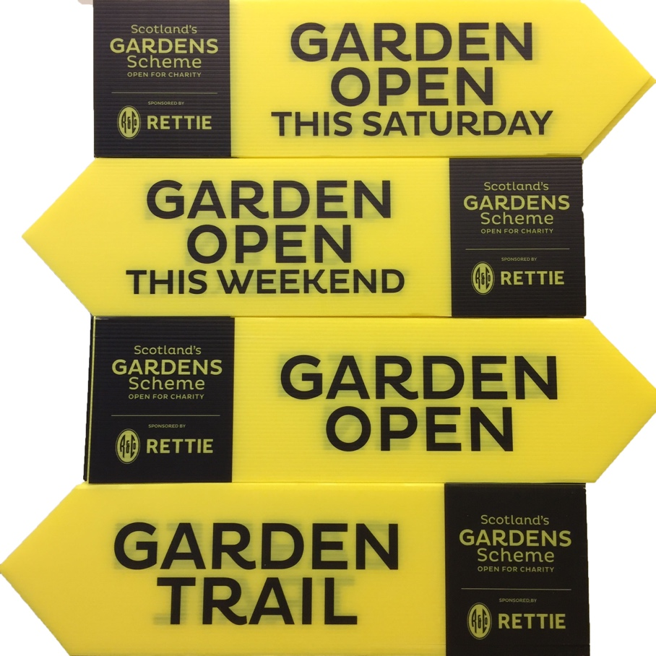

Introduction
Welcome! Thank you for opening with Scotland's Gardens Scheme. We hope you have a wonderful opening and that your garden owners and visitors really enjoy the experience. This guidance sets out key information to help villages and groups to open as safely as possible, including:
- Resources that Scotland’s Gardens Scheme can provide.
- Physical distancing in your gardens, queue management, signage and markings.
- Masks, hand hygiene, cleaning practices and toilet facilities.
- Payment options
- Teas and plant sales
- Advice on the number of volunteers you will need
- Responsible visitor guidance
- Lycetts Covid Risk Assessment for garden visits

- Scotland’s Gardens Scheme Resources
We will provide guidance and materials that can be printed at home, provided by your District Organiser, or that we can send to you from Head Office.
These include:
- Posters to advertise your opening.
- Road signs
- Signs that you can use to manage distancing, hand hygiene, flow of movement.
- Guidance on Plant Sales.
- Guidance on providing refreshments.
- We will also inform the public through our website and social media about your opening and any relevant changes/adaptations they should expect.
- Downloadable materials can be found here on our website: https://scotlandsgardens.org/covid19-resources-for-garden-openings/

- Physical distancing and managing your visitor numbers

- Think about each garden’s visitor capacity to ensure the physical distancing guidelines (currently 2m)
- How long does it take for visitors to get around the garden? Garden owners might need to give a gentle nudge in smaller gardens where capacity is more limited, and they have people waiting.
- Would you allow visitors to stop and have a picnic in large gardens?
- Please also consider the size of your parking facilities; will you need stewards to help with parking?
- Queue management for social distancing; consider this for parking, ticket sales, admission to a garden, serving refreshments and plant sales. We can provide signs to remind visitors of social distancing and you may want to place posters in key areas. We can also provide signs that ask people to wear a mask whilst queuing.
- You may like to consider having several ticket points so that one area does not get overcrowded, and people can start visiting gardens from different points in your village.
- Are there any local traffic or street management plans in place that you must consider?
- Are there points where you can create a one-way system either in a garden, at ticket sales, at a refreshment station or plant stall? We can provide you with signs and SGS arrows.

- Masks, Hand Hygiene, Cleaning Practices, Toilet Facilities
Masks
- The wearing of masks outside is currently not a public health requirement, however, volunteers might like to wear masks if this makes them feel more comfortable as they interact with the public, and you may wish to ask visitors to wear masks if they are queuing.
- Government guidance indicates that visors are not as effective as masks when used on their own. However, if someone is unable to wear a mask, a visor is the next best thing.
- Volunteers should wear masks at refreshment points when handling food and drink and should use hand sanitiser as appropriate. If possible, please provide access to hand washing facilities for volunteer helpers.

Surfaces & Sanitiser
- Hand-hygiene reminder signs and hand sanitiser can be placed in key areas, such as ticket sales, garden entry points, refreshment areas and plant sales.
- The cost of hand sanitiser can be deducted as an expense.
- Regularly use an antibacterial spray to wipe down tables, refreshment areas, etc.
- Please do what you can to remove situations for touching surfaces – such as leaving doors and gates open.
- Consider the use of social distancing marking in areas where queues normally form, and the adoption of a limited entry approach, with one in, one out (whilst avoiding the creation of additional bottlenecks).
Toilets
- As with all of our garden openings at any time, it is not advised to admit visitors into private homes and you are not obliged to provide toilet facilities.
- Toilet facilities can be helpful for village/group openings and you should check whether there are any community centres, pubs, cafes, restaurants, public toilets, etc, available for visitor use.
- Contact your local council to see whether public toilets will be re-opening.
- Ask your local pubs/cafes whether they are happy for visitors to use toilets (hopefully they will benefit from increased trade, too).
- Add the toilet location/s on your map (the map often acts as a group's ticket).
- In the unlikely event that your group is responsible for providing toilets for the opening, (for instance, some places have community toilets), use the guidance as appropriate, however, you are not responsible for cleaning council toilets!
- To enable good hand hygiene, consider making hand sanitiser available on entry to toilets where safe and practical and ensure suitable handwashing facilities including running water and liquid soap and suitable options for drying (either paper towels or hand driers) are available.
- Use signs and posters to build awareness of good handwashing technique, the need to increase handwashing frequency and to avoid touching your face, and to cough or sneeze into a tissue which is binned safely, or into your arm if a tissue is not available.
- Set clear use and cleaning guidance for toilets, with increased frequency of cleaning in line with usage. Use normal cleaning products, paying attention to frequently hand touched surfaces, and consider use of disposable cloths or paper roll to clean all hard surfaces. You may wish to put up a poster asking visitors to wipe the toilet seat when they leave and provide antiseptic wipes and a bin for them to use.
- Keep the facilities well ventilated, for example by fixing doors open where appropriate.
- Special care should be taken for cleaning of portable toilets and larger toilet blocks.
- Putting up a visible cleaning schedule can keep it up to date and visible for visitors.

- Payments
We have several different payment options. Please discuss with your District organiser or with Head Office to find out which one(s) will work best for you:
- Provide a bucket or container for admission payments/ donations. You should place a sign by the bucket stating the admission amount and requesting exact change only.
- We are piloting the use of ‘Square’, a cashless, easy-to-use payment method. Please speak to your District Organiser to find out whether this is available in your area.
- It is still possible to take cash payments, and this can often be the quickest way of processing visitor payments. We advise that volunteers wear gloves at the payment points and/or hand sanitise after each customer. Better still, ask the visitor to place funds directly in the bucket and you may decide an ‘exact money only’ policy and not offer change. Visitors are expecting this and it has worked successfully!
- Counting the money: wait 3 days after your opening to count funds raised. Use good hygiene while counting – plastic gloves/ hand sanitiser. Coins may be placed in boiling water before counting for extra reassurance.

- Teas and Plant Sales
Please see the separate guidance in this pack for Teas and Plant Sales

- Volunteer Numbers
- A village/ group opening is a large undertaking and it’s always good to have plenty of volunteers. During Covid-19, you might find it helpful to have extra volunteers to help with car parking, queuing, refreshments and plant sales, to manage the flow of people and to reduce queuing where possible.
- It might be helpful for some of your gardens to have a volunteer at the entry point to manage visitor numbers, help with queues and dispense hand sanitiser.
- Friends and family, local clubs and groups can all be helpful contacts to increase volunteer numbers on the day and it can be an enjoyable experience for them too.

- Visitor Guidance
We have found that visitors tend to be very respectful and knowledgeable about Covid-19 safety measures and are keen to follow protocols and guidance.
- General signs and templates that you can adapt for your needs can be found here on our website: https://scotlandsgardens.org/covid19-resources-for-garden-openings/
- You can download and print these yourself. Printing costs, including yellow paper which signs must be printed on, can be added to your expenses.
- Please ask your District Organiser first, as they may have some of these signs and/or a supply of yellow paper on which to print. Link to buy yellow paper: https://www.amazon.co.uk/Image-Coloraction-89608-Printing-Paper/dp/B002C2QQPC/ref=sr_1_1?dchild=1&keywords=Image+Coloraction+gold&qid=1618500139&s=officeproduct&sr=1-1

- What if we need to cancel?
We are able to cancel any listing with immediate effect and can also reinstate or change listings if you decide to open at a later date. If you need to cancel your opening, please let your local District Organiser know as soon as possible and they will get in touch with Head Office. We can then make people aware in the following ways:
- In our Guidebook - we always include a prominent notice asking people to check on the website for the latest news and updates for the garden they would like to visit.
- Our website – we have a very flexible website and as soon as we have a notification about a cancellation, we can update the listing as cancelled straightaway.
- We will promote the cancellation through our Social Media channels
- If the opening is cancelled far enough in advance, the office may be able to supply appropriate signage. Otherwise, a cancellation poster is available online for you to print out and display nearby in case any visitors arrive: https://scotlandsgardens.org/covid19-resources-for-garden-openings/

LIST OF APPENDICES:
- Plant Sale Guidance
- Refreshments Guidance
- Lycetts Covid Risk Assessment for garden visits

Updated April 2021

