Refreshments During Covid-19

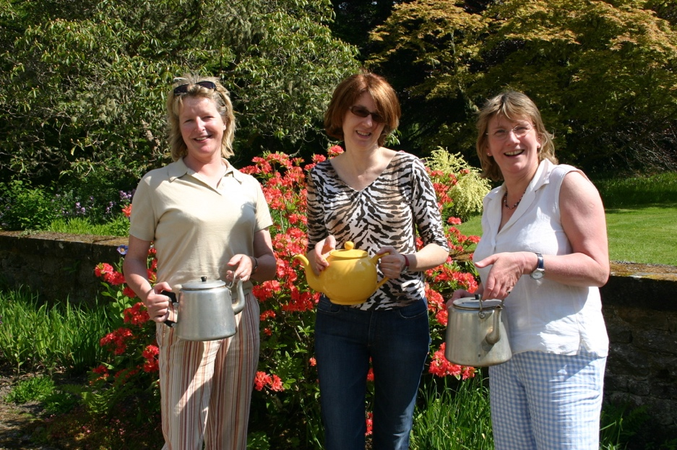

- Refreshments are a popular part of our garden openings. If you decide to provide refreshments this year, we would ask that you provide a takeaway option. This is because Government guidance for the hospitality trade clearly states that if you are providing seated refreshments, either indoors or outdoors, a track and trace system must be in operation. We do not have the ability to effectively upload the details of our visitors to the national system and so the simplest option is to provide a takeaway service only.
- For village or group openings you might like to consider involving a local café in the village as they may already be set-up to provide a safe take-away or sit-in service. They could donate a percentage of their takings. Mobile food trucks are also an option, and they too could be asked to donate a percentage of their takings on the day.
- You can encourage visitors to bring a picnic and a rug to sit on if you have space.
- Some gardens have encouraged visitors to bring their own cups, which cuts down on waste.

What refreshments will we offer?
- Keep it simple!
- Tea, coffee, bottled water, cartons of juice, mini tubs of milk, sugar sachets
- Disposable cups, cutlery, etc
- Individual cakes, scones, in bags/ boxes, packets of biscuits
- Prepare as much as possible beforehand so that serving is simple and quick on the day.
- We do not advise offering sandwiches.
- Make sure that good hygiene and food safety is followed in the preparation and serving of all food. Contact the office if you would like information about simple, online food safety courses.

Where will we serve refreshments?
- Hand sanitiser should be readily available at all refreshment points.
- Serve refreshments outside if possible – a gazebo is ideal as that will keep food and volunteers safe from the elements.
- If serving refreshments from an indoor point, please remember that volunteers and visitors must wear a face mask while they are inside and ensure a safe and consistent flow of people in and out – no indoor seating
- Consider having more than one refreshment station.
- Have a one-way system for each refreshment station.
- Decide on your payment method.
- Consider giving visitors the option of buying a tea ticket on entry. This can be redeemed at your refreshment station(s) and will help the flow of traffic.
- Please make sure that you have several, easily accessible waste bins near your refreshment station(s).

What about seating?
- We do not advise providing extra seating in addition to any garden seating that you already have in the garden, because of the track and trace requirement.
- However, people can be encouraged to bring fold-up seats, picnic blankets, etc.

How many volunteers will we need?
- Consider how many volunteers you will need on the day at each refreshment point for serving, payments, topping up cake trays, preparing boxes, managing queues, being a spare pair of hands, etc.
- Make sure volunteers have face masks and hand sanitiser.

Updated April 2021

