INFORMATION FOR
GARDEN OWNERS
Introduction / Planning your garden opening
Annual registration for your garden / Promoting your garden opening
Before the visitors arrive at your garden / ‘Insuring’ a successful day
After your garden opening / Useful contacts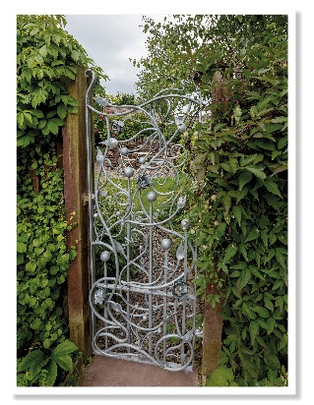
Sutherland Crescent, Perth & Kinross. Photography Mike Bell

Introduction

Thank you so much for deciding to open your garden for charity with Scotland’s Gardens Scheme (SGS). Your support will not only benefit the charities of your choice but also those supported by SGS: Maggie’s Cancer Caring Centres; Queen’s Nursing Institute Scotland (District Nurses); and Perennial (Gardeners’ Royal Benevolent Society). In addition, you will give a huge amount of pleasure to many visitors. You are joining a long tradition of community fundraising and we are pleased to welcome you.

For more information about our beneficiaries, please visit:
Maggie’s Cancer Caring Centres: https://www.maggiescentres.org
Queen’s Nursing Institute Scotland: https://www.qnis.org.uk
Perennial: http://perennial.org.uk

The SGS team, consisting of your local organising committee and SGS Head Office, has many years of experience, which we are very happy to share with you. We will provide a range of marketing materials and will actively help to promote your opening. We hope that the following information will help your opening to run smoothly, whether you are opening for the first time or are a seasoned garden opener.

Remember, it is your garden, and you are doing a wonderful service by opening it to the public for charity and we are incredibly appreciative of your hard work.

Thank you for opening your garden with Scotland’s Gardens Scheme.

Planning your garden opening

● how would you like to open your garden?
Type of opening
Category of opening

● Date(s) of opening

● Which charities will benefit?

● Admission charges

● Special attractions at your opening
Teas and other refreshments
Plants for sale
More ideas
Non-plant stalls

- WHAT TO DO IF YOU NEED TO CANCEL YOUR OPENING

COVID-19 - May 2021
PlEASE NOTE THAT WE HAVE PRODUCED ADDITIONAL GUIDANCE FOR GARDEN OPENING. THIS IS AVAILABLE AS AN APPENDIX TO THIS DOCUMENT AND SHOULD BE READ IN CONJUNCTION WITH THIS GUIDE.

Our guidance makes reference to queuing, one way systems, handling money, plant sales and refreshments, and we are reviewing this all the time so please do refer to our website or get in touch with head office if you need any advice or support. always refer to scottish government advice for the latest regulations.

HOWEVER....

We are so grateful to our wonderful Garden Owners who have paved the way by opening their gardens in 2020 after lockdown eased and shared their positive experiences of opening, giving confidence to others to follow suit and enabling us to learn from them.

Similarly, feedback from our Visitors has been so positive, with people so grateful to have the chance to get out and about in beautiful gardens again – your generosity and hard work is appreciated by all.

Covid 19 Website resources: https://scotlandsgardens.org/covid19-resources-for-garden-openings/

Including:

Cancellation Notice
Lycetts Covid Risk Assessment for Garden Visits
Covid Frequently Asked Questions for Garden Owners
Plant Sale Guidance during Covid
Print-at-home Covid Posters
Refreshments during Covid-19
Print-at-home posters - Visual signage for Covid
Visitor Guidance During Covid

You can also get the posters sent directly to you from the office, please speak to your District Organiser.

HOW would you like to open your garden?

Type of opening

By far the most successful way to open your garden with SGS is on a Specific Date, or on several dates. The most popular day is a Sunday, although Saturdays can also work well. Weekend openings are becoming more and more popular and prove especially helpful during times of year when weather can be particularly variable. The usual opening time is 2–5pm, although this is often extended, especially for village or group openings.

Some Garden Openers have regular openings over a Range of Dates. These do not tend to attract as many visitors as specific date openings; even over the season, the total takings are usually less than a Specific Date. However, this option may be appropriate for the needs of some.

You can also open By Arrangement, whereby visitors make a prior appointment to visit your garden. We have found that this type of opening does not bring many people unless a good amount of effort is made by the Garden Opener to reach potential visitors. However, it can work well for group visits, such as the Women’s Rural Institute (WRI) or gardening clubs, who like to arrange special visits for their members.

Note: many Garden Openers decide to choose a variety of the above open day types: for example, to be open on a Specific date(s) but also happy to have groups arrange to visit by appointment.

Category of Opening

In most cases you will be offering a garden opening. However, another possibility is to open as a Scotland’s Gardens Scheme Plant Sale, which should be coordinated with the local District. This kind of open day is very much focussed on the sale of plants, and it differs from an opening that happens to offer a plant stall. There may or may not be a garden open at the same time as an SGS Plant Sale opening.

And then, in more rare situations, you might be offering an event not related to either of the above, such as a workshop, music event or lecture.

For gardens who have already planned to open with us, you might consider a Pop-Up opening. There are a variety of reasons why this may be appropriate, for example:

- Your garden may be looking particularly lovely but is not scheduled to open.
- You may have already opened your garden, but the weather made attendance disappointing.
- You may have really enjoyed your Summer opening and would also like to open in the Autumn.

If you are interested in having a Pop-Up opening, please let your District Organiser know and they will be able to talk you through the process.

Date(s) for opening

You will want to choose a time of year when your garden looks at its best, though for some gardens this can be quite flexible. Do work closely with your District Organiser when selecting a date or dates, because they will be trying to create a schedule for all the garden open dates in the District, with minimal overlap. Sometimes, depending on the size of the District, two or more gardens may have to open on the same day, but we try to ensure that there is a good distance between these. Linking multiple gardens in the same area into a group opening can also be an option.

Which charities will benefit?

The money raised during your garden opening can be distributed in several ways:

- You can nominate a charity(s) of your choice to receive 60% of your opening day’s overall takings. This is a popular option. The elected charity(s) will often manage your teas during your opening, which could be invaluable.

- You can donate all the proceeds to Scotland’s Gardens Scheme. In this case the money raised, net of expenses, will go to SGS Beneficiaries, who are currently: Maggie’s Cancer Caring Centres; Queen’s Nursing Institute Scotland; and Perennial.

- The third option – to make a donation to SGS – is available only for gardens that open for other periods and have their own overheads to cover, such as a garden opens commercially. In this case, a minimum donation is expected, and the 60% elected charity may not be appropriate; discuss this with your District Organiser.

Admission charges
The average entrance fee for an SGS opening is £4-£5. For larger gardens and village openings, we recommend £6-£8. The appropriate amount can also vary by region across Scotland, so please seek guidance from your District Organiser.

The recommended admission prices do not include the cost of teas. We do not recommend including tea in the cost of admission, as this can lead to undercharging.

We ask you to please allow free entry to accompanied children as this will help make your opening more family friendly (basing child status on being accompanied by a parent will help you avoid the need to challenge guests and/or ask for ID). We also encourage that where visitors are accompanied by a Carer, the Carer is given free admission to the garden.

We recommend that you avoid the complication of multiple prices (e.g. a discount for OAPs).
Special attractions at your opening

Please note that the information in this section refers to a ‘normal’ year, however, in Covid-19 times, you must feel under no pressure whatsoever to offer teas or plant sales. However, some of our Garden Openers have found a number of creative ways to approach this during this time, and we share those experiences and top tips in the Covid resource section online.

Teas and Refreshments

A good assortment of homemade baking is always nice to offer to visitors and it’s often not that difficult to find people willing to do a bit of baking. It is not compulsory for you to provide teas, but it can make a big difference to the amount of money that you take. For some visitors, the main reason for coming is to enjoy the teas!

You might think it quite daunting to organise both the garden opening and the teas, yet often your nominated charity(s) will manage your teas. Contact them and see if they would be willing to do this. If they do organise the teas, they will need to hand over the takings so they can be counted along with the income from admissions and any stalls. Your elected charity(s) will then receive 60% of the day’s overall takings.

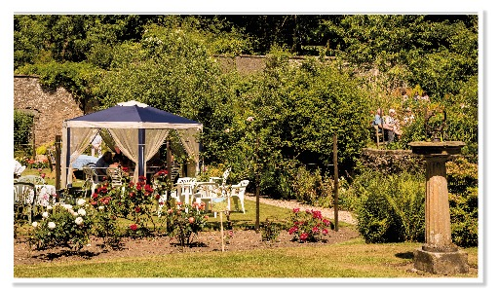
Teas at Glendoune House Walled Garden, Ayrshire. Photography David Blatchford

Occasionally, your chosen charity(s) may not be able to provide the teas: for example, where they have no local branch. In this case, contact your local District team or SGS Head Office, and we will try to find you support – from one of our Beneficiaries, for example. The remaining monies taken on your open day, net of expenses to promote and support your opening, will go to all SGS Beneficiaries.

If you are thinking of asking a commercial tearoom or outside caterer to organise the teas, please chat with your District Organiser first, to see if we can set up an alternative arrangement. However, we recognise that there are situations where it is best to contract out the teas. Indeed, this may be a good approach during Covid, and may help to support a local business. In this case a minimum of £10 plus 20% of the tea takings should be donated towards your open day.
Teas can be quite straightforward:

- tea or coffee, milk and sugar;
- squash;
- a variety of baking, such as biscuits, scones with cream or butter and jam, cakes and perhaps a savoury option of some kind.

However, you can also offer soup or another hot dish if appropriate.

All food must be stored/ maintained at an appropriate temperature in appropriate containers during your opening.

You must also think about food allergies and intolerances. Be sure to identify any baking that contains nuts and consider offering gluten-free and/or dairy-free options.

Price the teas simply with as few permutations of change as possible. During Covid, you should not be handling cash and so should ask for exact change only in a bucket or container. As a guide we suggest:

Basic teas (tea and biscuit) | minimum £1.50
Homemade teas | minimum £3.00
Cream teas | minimum £3.50
Hot Food | Minimum £3.00

You might want to offer a discount for children. Remember that you will need to arrange for a cash float for your teas, with change appropriate to your pricing structure.

Think about where you will serve the teas – a barn or outbuilding, gazebo, seated around the garden, even in a front hall (though do be mindful of security when having visitors in your house). How many people will you be able to seat? Consider that you will turn over those seats every 30–45 minutes. Then based on how long your opening will last, you can work out how many teas to prepare for: seats x number of 30 to 45 minute intervals. Ensure you have sufficient crockery, or paper cups and plates, to deal with such numbers. Your charity may be able to provide crockery, or else consider contacting a local church or village hall.

Inevitably, the weather will have a lot to do with your final number of visitors, but you can always sell off extra baking if you think you’ll have leftovers.

Plant Sale

A plant stall is a tremendous way of raising more funds, and where possible it is recommended that one is always set up. Visitors tend to support such a stall very strongly. Plants are generally sourced by the Garden Opener, friends and the local SGS team and are an excellent way of finding homes for surplus stock. Your local SGS team, or other openers across our network, can assist in the pricing of the plants if required.

On some occasions, a plant stall may be provided by a commercial plantsman/nursery. When this occurs, a minimum charge of £10 plus 20% of the sales should be donated to your overall day’s takings.

More Ideas

You might also, for example, want to organise a raffle, tombola or activities for children. These may or may not be fundraising – a children’s garden-based quiz would usually be free. We have ideas for children’s activities on our website in the Resources for Garden Openers section:

https://scotlandsgardens.org/resources/?tag_id=218

Selling SGS Guidebooks, particularly if you are opening early in the season, is helpful and also adds to your overall revenue. Tell your District team if you are willing to sell them; we are happy to let the takings be added to your day’s takings.

And finally, we will, from time to time, participate in special festivals and/or celebrations. If you are a current Garden Opener, we will invite you to join these events.

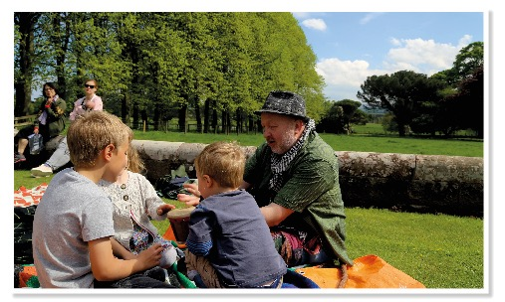
Storytelling at Tyninghame House and The Walled Garden, East Lothian
Other Stalls

You may wish, or be asked, to have additional stalls at your garden opening. These can increase the revenue from the day quite considerably, for little effort on your behalf. You need to provide the stallholders with a site and, in some cases, an electricity supply, water, even a table. Stallholders should be charged a minimum fee of £25 (or £10 plus 20% of turnover). You need to check that each stallholder has appropriate liability insurance for themselves and their products.

WHAT TO DO IF YOU NEED TO CANCEL YOUR OPENING

We know that occasionally garden owners need to cancel their opening. Please notify your District Organiser as soon as possible, so that they can tell Head Office and we can put a notice on our website. As the Guidebook is in the public domain, we can’t guarantee that everyone will be aware of the cancellation and so it is also helpful if you can do the following:

- Take down any posters advertising the opening and replace them with posters detailing the cancellation. The office can prepare this ‘cancelled’ poster and will send it to your District Organiser.
- If the opening has been advertised in the local press, the District Organiser will place a cancellation advert.
- On the opening day, please make sure that there are clear, prominent signs at the garden apologising for the cancellation and suggesting another garden or similar local attraction. Your District Organiser can help with suggestions and Head Office can prepare a poster.

We appreciate that sometimes time constraints mean that it’s not possible to do everything we have suggested, we just ask that you do what you can.

If appropriate, you might like to consider a ‘pop up’ opening later in the year.

Annual registration for your garden

Ensuring your information is up to date
Your privacy
Ensuring your information is relevant only to SGS
Descriptive information about your garden
Photographs
Group openings, villages and trails

Ensuring your information is up to date
Every autumn, SGS collects the information about garden openings and events for the following year, enabling us to have the Guidebook ready for the spring.

When you open for the first time with SGS, you will be asked by your local District committee to fill out the following:
• New Garden Registration Form
• New Contact Form
• Opening Dates & Times and Poster Orders Registration
This information will be added to our database, which powers our website, Guidebook and other related promotional activities. The District Volunteers will take care of this for you.

If, on the other hand, you have opened with us before, your local team will be in touch to check information for the coming year.

your privacy
At SGS we are committed to protecting your privacy. We will share information about your opening with the public, using our promotional activities unless you request that your opening remains private. We will share only the personal details you have chosen to publish. However, we may contact you to request permission to share your contact details with a journalist or party(s) interested in visiting your garden, but we will never release these details without first receiving your permission.

ENSURING YOUR INFORMATION IS RELEVANT ONLY TO SGS
Please note that SGS will only promote your charity opening times. This information is displayed in the guidebook and website as well as in various SGS promotional materials. Thus, all the information you provide on the type of opennig, dates for opening, catering and other features, and admission prices, must be relevant only for charity. If you also open your garden for other purposes and/or times, these opening dates and time are not deemed appropriate under your charity listing.

Descriptive information about your garden
The garden description is very important, and this will ‘sell’ your garden to potential visitors. It should be both succinct and inspiring, telling the reader what is special about your garden – such as your plant collections, architectural features, views. Also, when you fill out the new garden registration form, we ask you to identify any special features, or descriptive tags, about your garden. These should be exceptional qualities and are ‘searchable’ on our website.

Please add directions, as appropriate, to help people find your garden.

Finally, provide information about additional features, including:

Wheelchair access (full/partial/none)
Champion Trees, if you have any
National Plant Collection, if you hold one
Whether you allow dogs on lead to visit
Whether your garden can be reached by public transportation (include details of this in your directions)

Photographs
High quality photographs are essential to promote your garden, especially on the website, where we have room to feature a number of photographs. High-resolution photographs of your garden can encourage journalists to feature your garden in the media. Your photographs should work well with your garden description and any special features (above), displaying what has been described. Please note that journalists are especially interested in new gardens, so don’t miss your opportunity to get a bit of press coverage for your garden.

Group openings, villages and trails
If your garden is part of a group such as a village opening or linked with, or close to, other gardens, your local District committee will help to coordinate these openings. Each garden involved in the group will need to fill out registration forms for their garden as well as contact information. Your group will need to agree an opening date(s), beneficiary charity(s) and someone must agree to be the primary contact.

Promoting your garden opening

- Social and other media
- Posters and leaflets
- Newspapers
- Word of mouth
- Your nominated charity(s)

- OTHER PROMOTIONAL ACTIVITIES
Social and other media

In addition to your garden listing in SGS annual Guidebook (10,000 distributed each year), your garden will be described on our website (http://scotlandsgardens.org) and in regional leaflets distributed by your local SGS team (over 65,000 in 2018). We also promote through our central social media accounts:

- Facebook - https://www.facebook.com/scotlandsgardens
- Instagram - https://www.instagram.com/scotlandgardenscheme/
- Twitter - https://twitter.com/scotgardens

- and Pinterest (Scotland’s Gardens Scheme) accounts, and we provide our garden open listings to a variety of digital ‘what’s on’ networks across Scotland (eg, The List: https://www.list.co.uk). Many Districts also manage their own local Facebook pages.

Posters and leaflets

Posters with your opening details are available in a variety of sizes from your local District committee. You should order these as part of your annual registration process, using the Posters Orders form. You will probably be the best person to decide where these are placed: consider local newsagents, libraries, garden centres and tourism centres.

Newspapers

Where possible, SGS look to promote our garden open days through press releases to local papers, in order to avoid the expense of paid advertising. After all, local papers are interested in local stories and your hard work to open your private garden to the public for charitable purposes is just what journalists are looking for. Speak to your District team to find out more about how your garden will be promoted as they manage the local press releases.

We also look for opportunities for editorial stories, which can boost visitor numbers significantly. But, to do this, we must have photographs with good resolution of your garden. It’s also very helpful if you make sure that, through your garden description and use of garden features (above), we are aware of any special features in your garden – quirky and unique qualities always interest journalists.

Word of mouth
Never underestimate the value of ‘word of mouth’ as an essential reason why people come to your garden. When we run market research at openings, time and time again we learn that the majority of visitors are local (eg, come from within 30 miles) and they learnt of the garden opening through word of mouth (eg, the owner or a friend). So be sure to tell everyone you know that you’re opening your garden for charity.

Your nominated charity(s)
Your elected (60%) charity(s) should also help promote your opening to their network of supporters, thus widening your reach. Ask them to advertise your opening on their social media and in any relevant newsletters. If appropriate, have them help to put up your posters and offer SGS leaflets.

Other promotional activities
SGS will also arrange for a variety of additional promotional activities for your opening such as e-newsletter and website blogs. SGS send a monthly e-newsletter where we showcase a selection of garden openings via garden blogs and charity news. New openings are promoted on a monthly basis and other gardens are promoted by garden blogs. These blogs are usually collated around the gardens’ theme (e.g. coastal, roses, child-friendly activities) using your garden description and garden features (above), so make sure they are representative. A selection of these blogs are shown on the SGS home page of our website and are, therefore, the first thing a visitor will see when visiting the website. These blogs are swopped around weekly.

Before the visitors arrive at your garden

- Toilet facilities
- Plan for helpers on the day
- Road signs
- Car parking
- Map of the garden/village opening
- Internal garden signs
- Floats

Toilet facilities

During the pandemic, we are not recommending that you provide access to toilets inside your house, although access to hand sanitiser is important.

Especially when serving teas, you should consider how you might provide access to toilets and handwashing facilities. This can be especially important for more vulnerable visitors. If you are lucky, you will have a toilet in an outbuilding. If not, you’ll need to consider where nearby you can direct visitors or how you might provide safe access into your house. A Portaloo could be hired, but this will impact heavily on the funds raised.

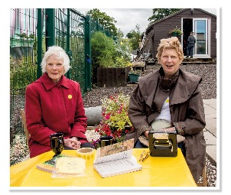
Plan for helpers on the day

You are going to need one or two people to manage your entrance arrangements, and probably others to supervise the parking.

You will also require helpers should you offer activities, a plant stall and/or teas. Hopefully, your elected charity(s) will relieve you of the tea responsibility but, if not, think carefully about how you will manage the teas: expect helpers to serve, clear, take money and wash dishes.

Ayrshire volunteers on the gate at Netherthird Community Garden.

Road signs
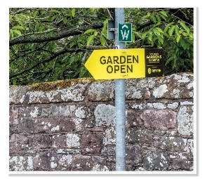
Is your garden easily found? The SGS annual Guidebook provides general directions but you can never underestimate the ability of people to get lost, despite the ubiquitous use of satellite navigation. So, plan to use road signs and banners, which will be supplied by your local SGS committee. These will include large yellow arrows and banners.
Earlier in the week of your garden opening, put up an SGS sign or banner with ‘Garden Open This Sunday’, for example, to prompt your local commuters to visit. Then, on the morning of your opening, place the other signs strategically at major local crossroads to lead visitors to your garden.

Car parking
Think about where it will be best for visitors to park. Depending on your layout, it may be helpful to design a one-way system for traffic in order to avoid bottlenecks. It’s also always worth having a contingency car parking plan for those days when the turnout exceeds your wildest dreams. In addition, do you need a Plan B for parking when the weather is very wet? And remember that you may require parking helpers.

You need to site the place where the entrance money is collected at a location which everyone has to pass to get into your garden. This might be at the entrance to your garden or to your car parking, or perhaps in a village/church hall in the case of a village opening.

Map of the garden/village opening
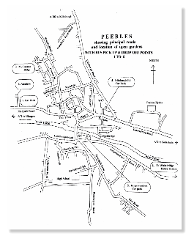
A simple map of your garden, especially if large, can be useful for visitors. For a village or group opening, a map really can be essential, to help everyone get from here to there. Nothing elaborate is required; in fact, simple can be easiest for everyone. The SGS Office can create a ticket with a map for your opening and your local District team can assist by testing your proposed map before your open day.

If your garden has wheelchair access, you must be prepared to explain particular aspects of this, as well as offer the option of Disabled Parking. Help these visitors understand how best to visit your garden.

Internal garden signs

Laminated signs within your garden will be provided by your local District team. These will include a selection of arrows and labels (such as entrance, car park, disabled parking, teas, plant stall, exit, no admittance), which you can place to help direct visitors appropriately around your garden. The SGS team will also be happy to create any special sign(s) that you might need: for example, ‘slippery when wet’ or ‘please keep off’.

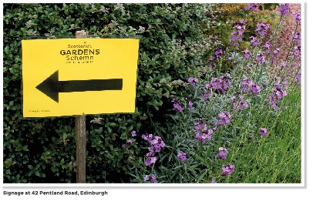

Floats

In addition to the entrance float, you will need to arrange floats for each of the paid activities you plan to have ‘on the go’: for example, teas, plant stall, non-plant stalls.

Remember to plan each float change to reflect the prices for that activity. The float at the entrance, for example, should relate to your admission price (and the inevitability of receiving several £20 notes in the first hour of opening). Lots of 50p coins will be needed if teas are priced at £3.50.

Note: It’s quite nice to provide the tea float even if you have asked your charity to manage this.

‘Insuring’ a successful day

● Risk assessment
● Liability insurance
Public liability
Employers’ liability
Product liability
Guidance in the event of an accident
● Security/Theft/Breakages

Risk assessment

It may sound a bit corporate, but it’s important that you run through a risk assessment of your garden. It’s really not as daunting as it sounds. You need to think about what sorts of things could go wrong, where someone might get hurt, and then consider what you might do to keep that from happening. So, sit down and make a list that includes:

- things that could be dangerous
- what you can do to prevent this

The following are examples for your list:

Things that could be dangerous | What you can do to prevent this
Children could go into your deep pond | Put up a special sign saying ‘Deep water, please keep children away’
If it’s a rainy day, someone might slip on your bridge | Put up a sign saying, ‘Slippery when wet’.
Overhanging or broken branches | Have a tree surgeon round before the open day to assess the health of all your trees
Children could get hurt on your climbing frame and trampoline | Decide whether to signpost each piece of equipment as ‘please keep off’ or as ‘equipment used entirely at user’s risk; parents must supervise children’; or else have the equipment supervised
Someone might get burnt by hot tea or coffee | Serve hot drinks to visitors only when seated at tables. Don’t allow visitors to serve themselves buffet-style; use take-away style cups with lids.

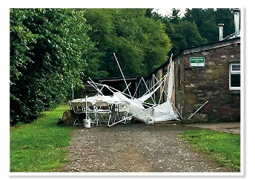
When things go wrong, a broken gazebo before an open day at The Herbalist’s Garden at Logie.

Note: We do not recommend charging for the use of equipment such as children’s play sets, because this implies a degree of responsibility on your behalf.
Liability insurance
It is, unfortunately, a symptom of our modern age that liability insurance is a topic that cannot be ignored. As such, SGS have arranged cover for Garden Openers and Organisers of plant sales.

The ‘liability’ to which we refer is public, employers’ and product liability. It is very easy to get over-concerned on the topic of insurance – trying to cross every ‘t’ and dot every ‘i’. Remember what is ‘reasonable’ to expect. If in doubt, please feel free to discuss this with your local helpers or SGS Office.

Public liability
This is essentially the duty of care, beholden upon all of us, to third parties. We are all expected to behave in a reasonable manner and take all reasonable steps to prevent undue hazard to others.

Even with the best will in the world, things can go wrong. A person may get injured as a result of your alleged inadequacies, and therefore seek redress. That is why the majority of household insurance policies have a section that gives cover providing protection against these circumstances. In the case of a garden opening or associated events, it is quite easy to think of a situation where something may go wrong. A loose stone step in a path causing a fall or a slippery surface.

SGS public liability insurance covers all owners who open their gardens or hold plant sales for the charity. However, this cover does not apply to garden openings that are not for the benefit of SGS, nor if the Garden Opener has other, more specific public liability insurance in place: for example, where a household, commercial or estate policy already provides cover for public garden opening.

Employers’ liability
In the same vein, SGS cover extends to include employers’ liability insurance in respect of Volunteers who help Garden Openers with the preparation of a garden opening or with its smooth running. This insurance also includes casual and occasional employees in so far as they have been involved with an SGS event.

Product liability
Producers have a responsibility for any injuries caused by their products. In the instance of a garden opening, one possible area of liability is the provision of teas and the food sold. Providing teas and food is a potentially fraught area. It would be absurd for a Volunteer who has provided scones etc. to take out a product liability policy, or even read every word on the subject produced by the Food Standards Agency. We would expect the word ‘reasonable’ to come into play in any claim – we are not talking here of a commercial enterprise such as a restaurant, where different and perhaps higher standards would apply. All one can expect is that ‘all reasonable precautions’ are taken to prevent injury to third parties. However, having the cover is a better option than not having it, and so SGS policy provides such cover.

It is equally important for stallholders to carry their own product liability insurance. If they do not, and a product’s claim does arise, you as the host may be targeted.

Guidance in the event of an accident:

Having an accident/ incident of any kind at your opening can be very stressful and upsetting. Your District Organiser (DO) and Head Office are here to help you. It is quite likely that a member of the District team will already be at your opening and will be able to assist you at the time. However, if this is not the case, please contact your District Organiser as soon as possible so that he/ she can support you through the process of documenting and reporting the accident/ incident. It is very important that you inform your DO and Head Office about any accident that occurs, or any incident such as an allergic reaction or food poisoning.

- Please do not make any admissions or concessions without speaking to Lycetts, our insurer, first.
- It is essential that our insurers are notified as quickly as possible, so please ensure that as soon as something happens that may result in a claim, you contact Lycetts. The easiest way to do this is by telephone: 0131 225 9119. They will ask you questions and take down all the details that they require.
- To help you answer their questions you should try and record as much information about the accident as possible such as:
  - Names and contact information of the injured persons and witnesses
  - Photos of the accident
- If you have any doubt about how to proceed please contact our insurers at Lycetts, either James Innes (james.innes@lycetts.co.uk) or Andy Cooper (andy.cooper@lycetts.co.uk) or telephone 0131 225 9119.

Security/Theft/Breakages

As you are inviting strangers onto your property, it makes sense to consider security and you should bear the following in mind:

- identify the area to which you want the public to have access, as well as those where access is to be restricted
- secure gardening equipment in sheds
- restrict access to the house, keep valuables out of sight and draw ground floor curtains
- secure the house as far as possible, locking doors and windows where appropriate.

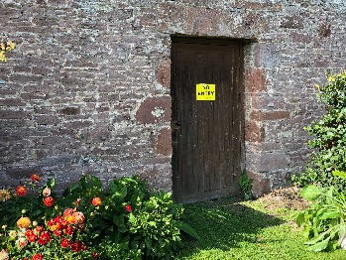

As SGS insurance does not cover theft or breakages, we strongly recommend you inform your own insurers that the garden opening is happening. Your insurers may simply note the fact or apply terms to your cover. Any terms may be unwelcome, but it is better to have restricted cover than none at all.

After your garden opening
Each District has its own Treasurer, who manages the finances for each of its openings. Before your opening, you should be contacted by your local Treasurer with instructions on how to report and submit the money raised at your opening. Remember that you should forward all the money raised at your opening to the Treasurer, who will see that your chosen charity(s) is paid and that a proper receipt is received from said charity(s). So please do not pay your charity(s) directly, or our auditors’ will begin to lose sleep … If you have not heard from your local Treasurer by the time of the opening, please get in touch with your local committee or SGS Office for an introduction.

Useful contacts

If you need anything, please consult the SGS team who are there to help you.

Your local District team

District Organiser:
District Treasurer:
Head Office contact details
Address: 23 Castle Street, Edinburgh EH2 3DN
Telephone: 0131 226 3714
Email:info@scotlandsgardens.org

Office Manager: Hazel Reid (hazel@scotlandsgardens.org)
National Organiser: Liz Stewart (liz@scotlandsgardens.org)
Marketing Manager: Daria Piskorz (daria@scotlandsgardens.org)
Volunteer Manager: Julie Golding (julie@scotlandsgardens.org)

We are always interested in your feedback, if you have any notes or comment please contact us.

